Notice
This is to inform all the students of B.A. Part III (Hons.) Geography that your Practical Examination will be held as per following routine in ONLINE MODEas per University Guideline. You will get question paper before commencing examination and submission of written answer script after completion of examination will be as per the time allotted by the University of Gour Banga.
Examination Routine for B.A. Part III (Hons.)
Date | Time | Paper
11.05.2022 | 11.00am-3pm | VI
12.05.2022 | 11.00am-3pm | VII
13.05.2022 | 11.00am-3pm | VIII
14.05.2022 | 11.00am-3pm | IX

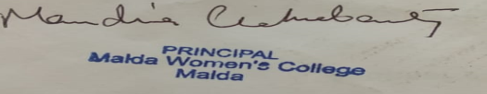
(Professor Mandira Chakraborty)
Principal, Malda Women’s College
Malda, West Bengal

